CENTRE FOR DANCE
Presents
DANCING IN THE STREET
June 9, 2024
MCFARLIN AUDITORIUM
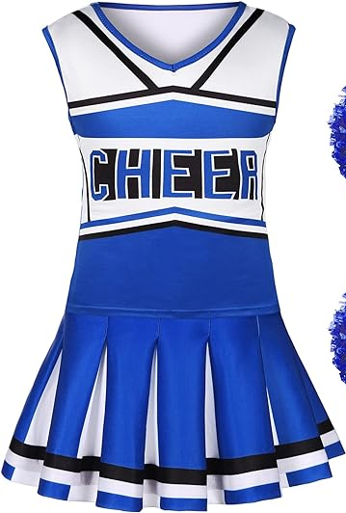
Your Class:
Elementary Cheer Dance 7–9-year-olds, Monday 6:00
Ms. Stephanie
“Welcome to New York”
Costume: Blue and two-piece cheer outfit.
Accessories: Studio provided poms.
Shoes: Sneakers (Predominantly white).
Tights: Skin tone
Hair: Low bun, center part, and bangs pulled back and out of face. This helps prevent shadow from being cast on your dancer’s face while on stage. Secure bun with bobby pins and a hair tie that matches the dancer’s hair color. We also recommend using a hair net around the bun that matches the dancer’s hair color, to control fly-aways. These items are available at Sally’s Beauty Supply or any other beauty supply store. Please see the attached photo and video link for the proper way to style your dancer’s hair.
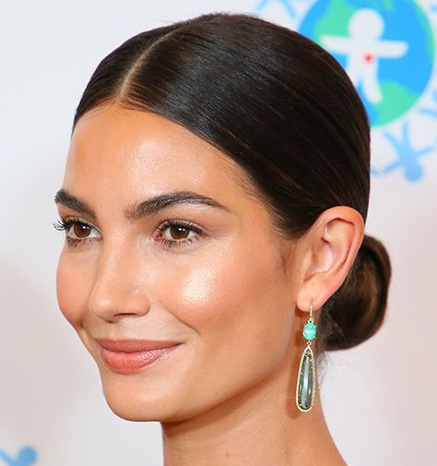
Makeup: Makeup should be worn due to the brightness of the stage lights. We encourage every dancer to wear warm colored eye shadow, lipstick, blush, and mascara. These are the basics and very important! No blue, green, purple or bright eyeshadow, and no deep red lipstick. **No nail polish, extra jewelry or accessories. **

Bun Tutorial | Low Bun with a Middle Part (youtube.com)

